

|  |
| --- |
| LAB REPORT  FUNDAMENTALS  2021 |
|  |
| September 28  Shaid Smarak College  Submitted by: Amir Maharjan |

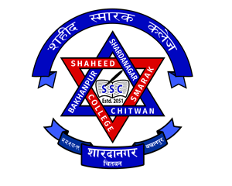

CLI based OS

Objective: To be able to use the commands when necessary and in need.

Introduction:

Command line interface (CLI) is a text-based interface that is used to operate software and operating systems while allowing the user to respond to visual prompts by typing single commands into the interface and receiving a reply in the same way. The program which handles the interface is called a command line interpreter or command line processor. It is also known as MS-DOS.

How does a command line work? The command line (also called the console or terminal) is a text-based interface within the operating system, that forwards commands from the user to the OS.

Types of DOS commands:

* Internal commands
* External commands

Commands of DOS:

1. CLS

It is a command that clear the screen in ms-dos, similar to Qbasic.

1. Date

This command displays the current date and also allows you to change the displayed date, if the user wants.

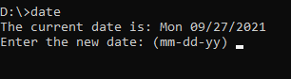

1. Time

This command displays the current time and allows you to change the displayed time if the user wants.

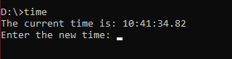

These were some of the internal commands of MS-DOS. Now, Lets look at some of the external commands of MS-DOS.

1. DIR

This command shows all the directories that are available in the drive.

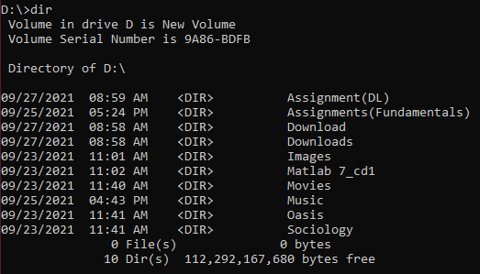

1. CD

This commands stands for change directory. To use this command the user needs to type (cd file name).



1. CD..

This commands is the exact opposite of CD. The CD command forwards while the CD.. commands backwards.

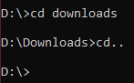

1. MD

This command stands for make directory. It makes a directory in the selected drive.

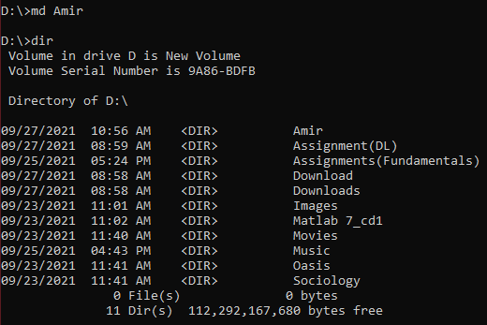

1. RD

This command stands for remove directory. It deletes a directory form the selected drive. Another command to delete a directory is DEL. RD Filename or DEL filename.

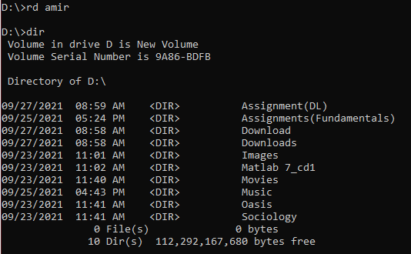

1. Copy con

This command creates a txt file and the user can write whatever he/she wants and to save the file press ctrl+Z. Copy Con Filename.



1. TYPE

This command displays all the text file. Type filename.



1. CHANGE DRIVE

The command to change drive is quite simple. The command is D:

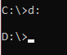

9. TREE

The TREE command is used to display all the directory and the sub-directory in the drive.

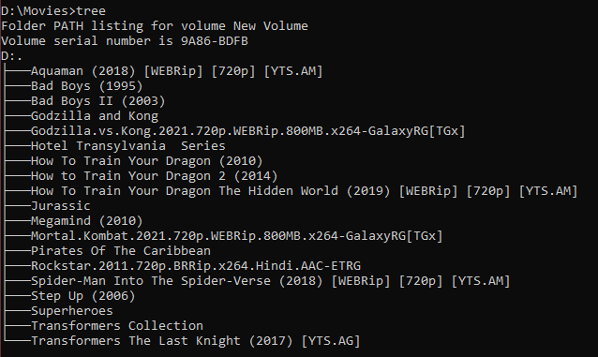

10. DELTREE

This command is used to delete the directory with all its contents.

11. LABEL

This command is used to rename a drive.

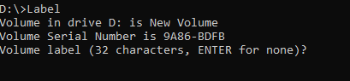

12. CHKDSK

This command stands for check disk. When this command is given it checks the drive and the report is displayed on the screen.

13. IPCONFIG

This command provides the ip address, gateway, etc. If you are connected to any wifi or ethernet.

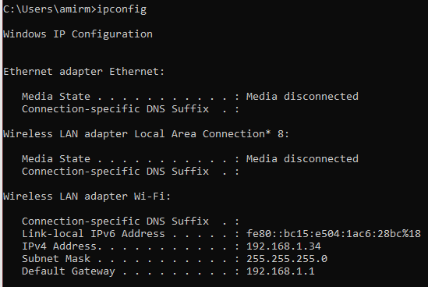

14. PING

This command check if the wifi or ethernet you are connected to is properly working or not. PING 192.168.1.1 (enter).

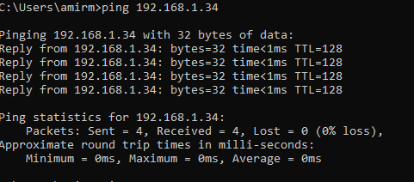

15. TRACERT

This command can traces all the paths your computer or device takes until it reaches its destination.

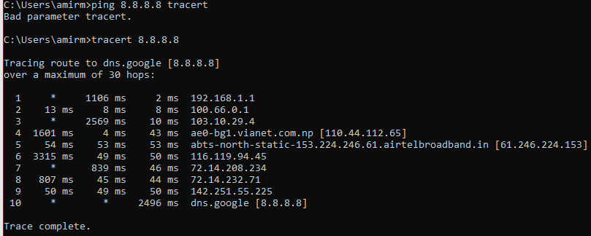

Note: 8.8.8.8 is the primary DNS server of Google DNS.

Thank You